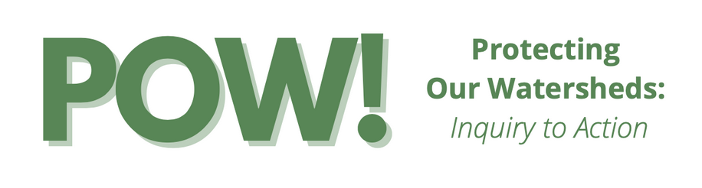
POW! 4th Grade Lesson Plan

Lesson 1: Soil

Lesson Title: | Exploring Local Soils
Grade Level: | 4th
Learning Experience  Description | Students will learn about soil and its importance. Soil, weathering, and erosion provide a foundation for thinking about the formation of landscapes and lead us into topics of ecosystems and food webs. Students will also explore local soils and demonstrate creative thinking by using local soils for artwork.
Prior Learning Needed: | None
Time: | Part A: 20 minutes  Part B: 30-45 minutes  Part C: 1 hour (split into 2 days, or can assign time at home)
Standards
Science:

4-ESS1-1 (Foundational): Identify evidence from patterns in rock formations and fossils in rock layers to support an explanation for changes in a landscape over time.

4-ESS2-1 (Foundational): Make observations and/or measurements to provide evidence of the effects of weathering or the rate of erosion by water, ice, wind, or vegetation.

Art:

4.VA:Cr1.1
Brainstorm individual and collaborative approaches to a creative art or design problem.
4.VA:Cr1.2
Collaboratively set goals and create artwork that is meaningful and has purpose to the makers.
4.VA:Cr2.2
When making works of art, utilize and care for materials, tools, and equipment in a manner that prevents danger to oneself and others.
4.VA:Cr3
Revise artwork in progress on the basis of insights gained through peer discussion.
ELA:

CA Environmental Principles and Concepts:
Principle 1:
Concept A. The goods produced by natural systems are essential to human life and to the functioning of our economies and cultures.
Concept B. The ecosystem services provided by natural systems are essential to human life and to the functioning of our economies and cultures.
Principle 3:
Concept A. Natural systems proceed through cycles and processes that are required for their functioning.
Career Technical Education (CTE) : ( Technical Skills)
Agriculture and Natural Resources

Potential Career Paths:
Soil Scientist- A soil scientist studies the upper few meters of the Earth’s crust in terms of its physical and chemical properties; distribution, genesis and morphology; and biological components. A soil scientist needs a strong background in the physical and biological sciences and mathematics. The job of a soil scientist includes collection of soil data, consultation, investigation, evaluation, interpretation, planning or inspection relating to soil science. This career includes many different assignments and involves making recommendations about many resource areas.
Success Skills: Check the success skills that are present in the lesson.
- Communication | - Empathy
- Collaboration | - Flexibility
- Creativity | - Leadership
- Critical Thinking | - Perseverance

Essential Question | What is soil, how is soil formed, and why is soil important?
Learning Progression | Soil sets the stage for landscape formations, and then connects to ecosystems and food webs.
Learning Intentions  “I am learning” | I am learning what soil is made up of. I am learning why soil is important.
Success Criteria  “I can” | I can describe different soil materials. I can identify organic material. I can use soil in a creative way. I can express how soil is important to me through different artforms.
Academic Vocabulary | Soil  Earth materials  Organic materials  Rock  Pebbles  Gravel  Sand  Silt  Clay  Decay
Classroom Management Needs | - In part A, student observations while outdoors sorting through soil samples.  - In parts B and C, ensure proper care of soil art supplies and iInnovate equipment  - In part C, ensure each student is participating in group assignment
Business / Industry Involvement (field trips guest speakers) | Soil science - Dr. Yamina Pressler (video)
Materials/  Innovation Lab Use | Slide Deck  Lesson 1A:  Paper plate/paper towel  Notebook/piece of paper  Writing tool  Video introducing soil scientist - Dr. Yamina Pressler  Lesson 1B:  Soil paint palettes or paint dot cards  Paintbrushes  Cups of water  Paper towels  Watercolor paper cut into long pieces (fold paper into thirds as if into an envelope for size)  Scrap pieces of paper (size 4X4 inches)  Video with Dr. Pressler leading soil painting activity  Lesson 1C:  Notebook/piece of paper  Writing tool  Camera / iPad (to take image for Green Screen)  Green Screen and video camera use in iInnovate Lab
Learning Experience Design Plan
Focused Instruction  Modeling, stated learning intentions | - Teacher tells the students we will be using a natural resource to make art - we are going to use local soils! But first we must learn what soil is made up of.  - This lesson is in 3 parts. In part A we will learn about soil and we will explore soil around us. Then in part B we will use soil paint for artwork. Lastly in part C, we will use the artwork we created to help express why soil is important to us.
Guided instruction  Prompts, Cues, Questioning | - Before we begin, we will need to go through the slide deck to learn about soils.  - Teacher can assign the slide deck to students asynchronously, or teach the slide deck together in class.  - When it is activity time, guide students outside to explore soil around their school (or if learning at home, in their own backyard). Talk in groups about their findings. Did they have any questions? What kind of soil did they find? Why did they find some soils and not others? Could the soil they found grow food?  - In part A, students watch a video featuring Yamina Pressler explaining what a soil scientist is, what she does, and why it’s important.  - In part B, teacher explains that today students will be creating their own piece of art - but instead of using paints, they are using local soil samples.  - Students are guided through the soil art activity video with Dr. Yamina Pressler.  - In part C, students finish the prompt “Soil is important to me because…” through artistic expression and creativity. They will take a photo of their artwork and use it as the background for the green screen in the iInnovate lab.
Collaborative learning  Student to student structures, 50% instructional time, Accountability | - Part A: Students can share what they found in their soils with other students.  - Part B: Part way through their soil art painting, you can have students share and make suggestions for continuing their work.  - If desired for Part C, you can have students work in groups.
Independent Learning  Practice, Apply, Transfer | - In part A, apply knowledge of soil materials to categorize their soil samples.  - Transfer understanding of smallest soil earth materials being used for soil paint.  - If desired for Part C, you can have students work independently.
Check for Understanding  Formal, informal structures | Slide deck has informal checkpoints at the end of part A and before moving on to part B.
Assessment  Rubrics, Products, Projects, Presentations  self-assessments | Project Rubric- Creativity and Innovation  Presentation Rubric  In part C students will use their artwork as a foundation to explain their connection to soil and why soil is important to them through the form of a presentation using a creative expression of their choice.
Closure  Exit tickets, feedback for next lesson | Soil is important to support all forms of life - but not all soil is the same. How does soil move or change over time? Next lesson we will explore weathering.

